**Obstacle Detection Sub-System Requirements Specification**

**1. Scope.**

* 1. **Identification.**

This document applies to the Obstacle Detection System (OD), a sub-system of the Automated Vehicle System (AVS).

AVS – Automated Vehicle System

MF – Mounting Frame

WC – Wireless Communications

MC – Motor Control

NM – Navigation and Mazing

OD – Obstacle Detection

LS – Location via Pozyx

UI – User interface

CH – RC Chassis

OP – On-board power

* 1. **Overview.**

The obstacle sensing system shall utilise the HC-SR04 Ultrasonic sensor Arduino module to calculate the distance to any objects within its range. Using the location and Euler angles data from the Location System it shall then calculate the grid reference containing the object, and output this to the navigation system. This will allow the Navigation System to perform improved, more informed route planning.

* 1. **Document overview.**

This document shall outline the high-level sub-system requirements of the Obstacle Detection System (OD), which is a sub-system on the Autonomous Vehicle System (AVS). Each requirement will be given a unique requirement ID (AVS-OD-XX), a planned Verification method, Traceable requirements, rationale/explanation and the related states/modes. This document will then be used in the future to drive further low-level requirements setting and design of the OD, in order to meet the system level requirement statements of the AVS.

**2. Referenced documents.**

**2.1 Stakeholder requirements:**

**2.1.1** Project Brief: Autonomous Indoor Navigation of an Unmanned Ground Vehicle Version 1 Mar 2018

**2.2 Autonomous Vehicle System Documentation**

**2.2.1** Autonomous Vehicle Requirements Specification Version 1 23/03/2018

**2.3 Other:**

**2.3.1** Arduino Uno Information Page 22/03/2018

**2.3.2** DHT22 Datasheet

**2.3.3** DHT11 Datasheet

**2.3.4** TMP36 Datasheet

**2.3.5** LM35DZ Datasheet

**2.3.6** Obstacle Detection System - Theoretical Overview (Annex A.)

**2.3.7** Obstacle Detection System - Hardware Component Decision Analysis (Annex B.)

**3. Requirements.**

**3.1 Required states and modes.**

Not used.

**3.2 Function and performance requirements.**

**3.2.1 Obstacle Detection Range Requirements.**

|  |  |
| --- | --- |
| **Requirement ID:**  AVS-OD-01 | **Requirement Statement**  The Obstacle Detection System shall detect obstacles inside the grid, to 95% reliability at a minimum of 10cm. |
| **Verification Method**  Demonstration | **Verification Description**  The ODS sensors’ range shall be demonstrated on a non-integrated circuit (i.e. breadboard), by aiming them at an obstacle 10cm away 100 times and checking output grid reference matches required reliability.  Once integrated onto the AVS the ODS shall be demonstrated while the AVS is both moving and stationery, by placing obstacles in known grid locations and confirming that the ODS outputs the correct grid reference. |
| **Traceability**  AVS-22 | **Rationale/explanation**  The given grid space has grid squares with size of 50x50cm hence for the AVS to detect an obstacle in any box directly adjacent, when the AVS is located in the centre of the current box, the lower limit of 10cm allows for sensors to be offset from the centre of the AVS by up to 40cm if required. |
| **States/Modes applicability:**  Not used | |

**3.2.x Obstacle Detection Accuracy Requirements.**

|  |  |
| --- | --- |
| **Requirement ID:**  AVS-OD-02 | **Requirement Statement**  The Obstacle Detection System shall detect obstacles within range to an accuracy of $±24cm$ |
| **Verification Method**  Demonstration | **Verification Description**  The ODS sensors’ range shall be demonstrated on a non-integrated circuit (i.e. breadboard), by aiming them at obstacles at various known ranges and checking output distance is within limits.  Once integrated onto the AVS the ODS shall be demonstrated while the AVS is both moving and stationery, by placing obstacles at various known distances and checking output distance is within limits. |
| **Traceability**  AVS-22 | **Rationale/explanation**  The given grid space has grid squares with size of 50x50cm hence to accurately allocate an obstacle to a grid reference, the obstacle must round up or down to the correct reference. |
| **States/Modes applicability:**  Not used | |

**3.2.2 Inputs Conversion To Obstacle Grid Reference Requirements**

|  |  |
| --- | --- |
| **Requirement ID:**  AVS-OD-03 | **Requirement Statement**  The Obstacle Detection System shall convert inputs from the range sensors (distance to detected obstacle) and the Location System (current AVS location and heading) into a grid reference representing the location of an obstacle. |
| **Verification Method**  Test | **Verification Description**  Before full integration, the Location System and OD shall be interfaced in the test grid, with a number of obstacles at different known grid locations. The full system will be emulated by outputting the OD output grid references to a Serial Monitor, confirming correct locations from each of the sensors in their respective directions. |
| **Traceability**  AVS-22 | **Rationale/explanation**  Once the ODS has received necessary inputs, this information must be combined in a useful way, i.e. to calculate the location of the detected obstacle. |
| **States/Modes applicability:**  Not used. | |

**3.3 External interface requirements.**

**3.3.1 Interface identification and diagrams.**

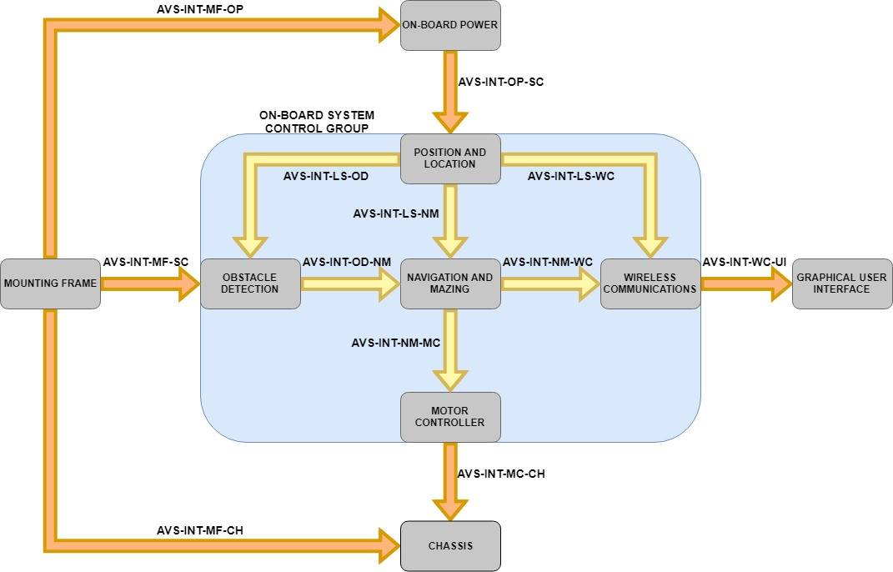

Figure 1: AVS Interface Diagram

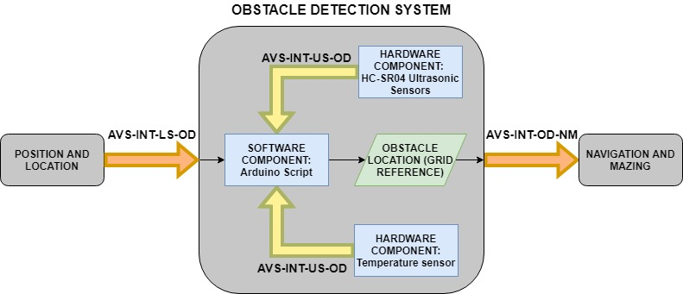

Figure 2: Obstacle Detection System Interfaces Diagram

**3.3.2 ODS and Location System Interface (AVS-INT-LS-OD) – Current Location Requirements**

|  |  |
| --- | --- |
| **Requirement ID:**  AVS-OD-04 | **Requirement Statement**  The Obstacle Detection System shall interface with the Location System receiving current location as an input. |
| **Verification Method**  Demonstration | **Verification Description**  Before full system integration, known input shall be fed to the OD to confirm it receives correct inputs.  Upon full system integration, the same testing will occur to ensure geometry is correct. |
| **Traceability**  AVS-22 | **Rationale/explanation**  For the ODS to correctly calculate the grid square of the detected obstacle, the AVS location inside the grid reference must be known in order to conduct the geometric calculations. |
| **States/Modes applicability:**  Not used | |

**3.3.3 ODS and Location System Interface (AVS-INT-LS-OD) – Current Heading Angle Requirements**

|  |  |
| --- | --- |
| **Requirement ID:**  AVS-OD-05 | **Requirement Statement**  The Obstacle Detection System shall interface with the Location System receiving current heading angle as an input. |
| **Verification Method**  Demonstration | **Verification Description**  Before full system integration, known input shall be fed to the OD to confirm it receives correct inputs.  Upon full system integration, the same testing will occur to ensure geometry is correct. |
| **Traceability**  AVS-22 | **Rationale/explanation**  For the ODS to correctly calculate the grid square of the detected obstacle, the AVS location and heading inside the grid reference must be known in order to conduct the geometric calculations. |
| **States/Modes applicability:**  Not used | |

**3.3.4 ODS and Navigation System Interface (AVS-INT-OD-NM) – Obstacle Location Requirements**

|  |  |
| --- | --- |
| **Requirement ID:**  AVS-OD-06 | **Requirement Statement**  The Obstacle Detection System shall interface with the Navigation System, outputting the correct grid references of detected obstacles to the Navigation System. |
| **Verification Method**  Demonstration | **Verification Description**  Before full system integration, and after the first stage testing of requirement AVS-ODS-03 is verified, the Location System and ODS shall be interfaced with the Navigation System and placed in the test grid, with obstacles at known locations, confirming that the in range obstacles are added to the Navigation System’s obstacle list. |
| **Traceability**  AVS-22 | **Rationale/explanation**  Once the ODS has calculated the location of the obstacle, it must output its findings to the navigation system for more informed route planning. |
| **States/Modes applicability:**  Not used. | |

**3.3.x Obstacle Detection System and HC-SR04 Internal Hardware Interface** **(AVS-INT-US-OD)**

|  |  |
| --- | --- |
| **Requirement ID:**  AVS-OD-07 | **Requirement Statement**  The Obstacle Detection System shall internally interface with the HC-SR04 Ultrasonic Sensors to receive distance to detected obstacle as an input. |
| **Verification Method**  Demonstration | **Verification Description**  Before full system integration a Serial Monitor will be setup to confirm that the Arduino is receiving distance data from the HC-SR04. |
| **Traceability**  AVS-30 | **Rationale/explanation**  Once the ODS has calculated the location of the obstacle, it must output its findings to the navigation system for more informed route planning. |
| **States/Modes applicability:**  Not used. | |

**3.3.x Obstacle Detection System and Chosen Temperature Sensor Internal Hardware Interface** – IF REQUIRED

**(AVS-INT-US-OD)**

|  |  |
| --- | --- |
| **Requirement ID:**  AVS-OD-08 | **Requirement Statement**  The Obstacle Detection System shall internally interface with the HC-SR04 Ultrasonic Sensors to receive distance to detected obstacle as an input. |
| **Verification Method**  Demonstration | **Verification Description**  Before full system integration a Serial Monitor will be setup to confirm that the Arduino is receiving distance data from the HC-SR04. |
| **Traceability**  AVS-30 | **Rationale/explanation**  Once the ODS has calculated the location of the obstacle, it must output its findings to the navigation system for more informed route planning. |
| **States/Modes applicability:**  Not used. | |

**3.4 Safety requirements.**

Not used.

**3.5 Security requirements.**

Not used.

**3.6 System environment requirements.**

Not used.

**3.7 System quality factors.**

**3.7.1 High Integrity C++ Version 4.0 Standards**

|  |  |
| --- | --- |
| **Requirement ID:**  AVS-OD-09 | **Requirement Statement**  The Obstacle Detection System Arduino script shall be in accordance with the High Integrity C++ Version 4.0 Standards |
| **Verification Method**  Inspection | **Verification Description**  The script will be inspected at the mid-point and end of each milestone and compared against the Version 4.0 Standards documentation. |
| **Traceability**  AVS-31 | **Rationale/explanation**  For the purpose of maintainability and usability, enabling other users to make changes in the future. It will also ensure efficient programming so as to fit on the 32Kb of Arduino built-in memory. |
| **States/Modes applicability:**  Not used. | |

**3.8 Appearance and surface finishing requirements.**

Not used.

**3.9 Design and construction constraints.**

**3.9.1 Arduino microcontroller**

|  |  |
| --- | --- |
| **Requirement ID:**  AVS-OD-10 | **Requirement Statement**  The Obstacle Detection System shall be implemented fully on the Arduino microcontroller (software and hardware components). |
| **Verification Method**  Inspection | **Verification Description**  The system will be inspected to ensure no reliance on any other hardware devices. |
| **Traceability**  AVS-30 | **Rationale/explanation**  Requirement set by the stakeholder in order to allow for complete wireless operation. |
| **States/Modes applicability:**  Not used. | |

**3.9.2 Battery constraints**

|  |  |
| --- | --- |
| **Requirement ID:**  AVS-OD-11 | **Requirement Statement**  The Obstacle Detection System shall be solely reliant on on-board available battery for all power requirements. |
| **Verification Method**  Inspection | **Verification Description**  The system will be inspected to confirm all power is coming from on-board batteries (i.e. no attached power cables). |
| **Traceability**  AVS-09 | **Rationale/explanation**  Requirement set by stakeholder in order to allow for complete wireless operation. |
| **States/Modes applicability:**  Not used. | |

**3.9.3 HC-SR04 Ultra sonic sensors**

|  |  |
| --- | --- |
| **Requirement ID:**  AVS-OD-12 | **Requirement Statement**  The Obstacle Detection System shall be solely reliant on the 3x HC-SR04 provided for obstacle detection. |
| **Verification Method**  Inspection | **Verification Description**  The system will be inspected to confirm that no other obstacle/distance sensors have been used. |
| **Traceability**  AVS-30 | **Rationale/explanation**  Requirement set by stakeholder due to availability and budget. |
| **States/Modes applicability:**  Not used. | |

**3.9.4 Arduino Compatible Programming Language**

|  |  |
| --- | --- |
| **Requirement ID:**  AVS-OD-13 | **Requirement Statement**  The Obstacle Detection System scripting shall be in an Arduino compatible programming language. |
| **Verification Method**  Demonstration | **Verification Description**  The system will be run to confirm that the ODS scripts run on the Arduino. |
| **Traceability**  AVS-30 | **Rationale/explanation**  The Arduino Uno is the microcontroller in use and hence the programming language and scripts must be compatible with this to ensure system works. |
| **States/Modes applicability:**  Not used. | |

**3.9.5**

**3.10- Personnel-related requirements**.

Not used.

**3.11 Training-related requirements.**

Not used.

**3.12 Support-related requirements.**

Not used.

**3.13 Other requirements.**

|  |  |
| --- | --- |
| **Requirement ID:**  AVS-OD-14 | **Requirement Statement**  The Obstacle Detection System milestones shall adhere to timeframes outlined in the Project Plan timings Gantt chart. |
| **Verification Method**  Inspection | **Verification Description**  At the end of each phase the milestones will be checked against the project plan to confirm timings have been met, and to confirm the timings of the next milestone. |
| **Traceability** | **Rationale/explanation**  To deliver the final project on time, smaller milestones are required along the way to ensure progress is being made and the project isn’t falling behind. |
| **States/Modes applicability:**  Not used. | |

**6. Notes.**

Not used.

**A. Appendices.**

**A.** Obstacle Detection System – Theoretical Overview

**B.** Obstacle Detection System – Hardware Component Decision Analysis